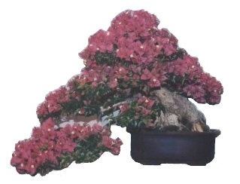**Brisbane**

**International**

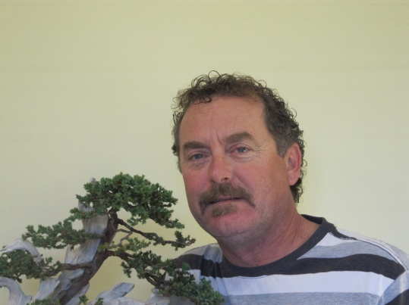**Bonsai**

**School**

**Growing Knowledge with Passion Tony Bebb – Principal**

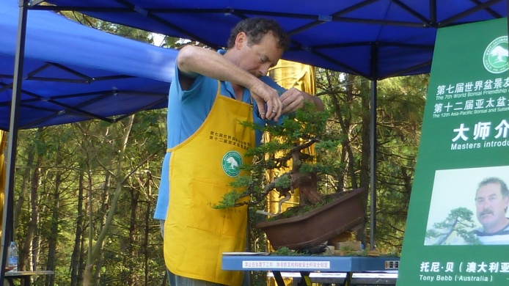One of only 2 Australians to demonstrate among 44 ‘Masters of Bonsai Creation’ from 22 different countries at the WBFF World Bonsai Convention in China, Sept 2013, Tony will also be the feature artist at the New Zealand National Bonsai Convention in May 2014 and demonstrate at the Bonsai Clubs International Bonsai Convention in August 2014. He has been working as a Bonsai professional for 30 years and has taught Bonsai all around Australia and New Zealand since 1997 and his thirst for knowledge is exceeded only by his passion for sharing it.

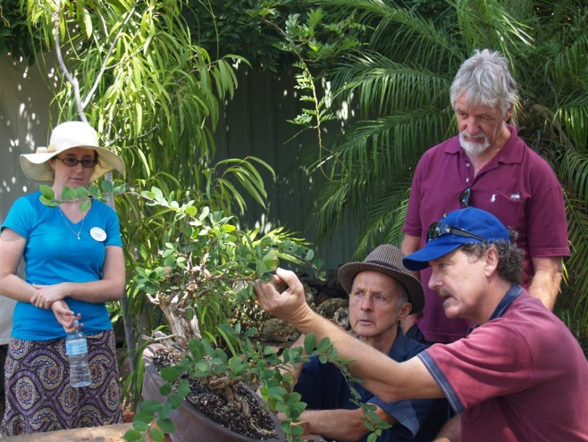Tony has developed a structured range of classes honouring Classical Bonsai Teaching Principles and shares his knowledge freely at any level of Bonsai education.Wether you want to learn just the fundamentals of Bonsai creation, care and maintenance, or extend your knowledge through to advanced techniques**,** Tony’s passion for teaching and creating Bonsai is the basis of his reputation and he is well respected around Australia and New Zealand for his creative vision and his willingness and ease at sharing his knowledge.

Come and Discover the World of Bonsai Creation and Relaxation at Brisbane International Bonsai School